**IIT HYDERABAD**

**A BRIEF INTRODUCTION TO 3D PRINTERS**

**Dhilli Venkata sai**

**Pilli Venkata Praneeth**

**Table of contents**

1. Introduction To 3D Printing
   * 1. Working Principle of 3D printers
     2. Parts of the 3D printer
     3. Functionality of each part
2. How to operate the 3D printers
   * + 1. How to setup for the print
       2. How to print the design

How to Slice the Designs

1. Parameters for commonly used filaments
2. Challenges faced during printing
3. How to update firmware for the 3D printers

**1.) Introduction To 3D Printing**

3D printing or additive manufacturing is a process of making three dimensional solid objects from a digital file.

The creation of a 3D printed object is achieved using additive processes. In an additive process an object is created by laying down successive layers of material until the object is created. Each of these layers can be seen as a thinly sliced cross-section of the object.

3D printing is the opposite of subtractive manufacturing which is cutting out / hollowing out a piece of metal or plastic with for instance a milling machine.

3D printing enables you to produce complex shapes using less material than traditional manufacturing methods.

**Examples of 3D Printing**

3D printing encompasses many forms of technologies and materials as 3D printing is being used in almost all industries you could think of. It’s important to see it as a cluster of diverse industries with a myriad of differentapplications.

A few examples:

* – consumer products (eyewear, footwear, design, furniture)
* – industrial products (manufacturing tools, prototypes, functional end-use parts)
* – dental products
* – prosthetics
* – architectural scale models & maquettes
* – reconstructing fossils
* – replicating ancient artefacts
* – reconstructing evidence in forensic pathology
* – movie props

**Why use 3D Printers for Rapid Prototyping?**

In short: it’s fast and relatively cheap. From idea, to 3D model to holding a prototype in your hands is a matter of days instead of weeks. Iterations are easier and cheaper to make and you don’t need expensive molds or tools.

Besides rapid prototyping, 3D printing is also used for **rapid manufacturing**. Rapid manufacturing is a new method of manufacturing where businesses use 3D printers for short run / small batch custom manufacturing.

1. **Working Principle of 3D printers**

All 3D printing techniques are based on the same principle: a 3D printer takes a digital model (as input) and turns it into a physical three-dimensional object by adding material layer by layer.

It is way different than traditional manufacturing processes such as injection molding and CNC machining that uses various cutting tools to construct the desired structure from a solid block. 3D Printing, however, requires no cutting tools: objects are manufactured directly onto the built platform.

The printer we use in the lab is creality cr 10s pro, this printer also holds the same working principle like other 3d printers available in the market .It has an extra feature compared to generic printers that is bed and extruder auto leveling using a proximity sensor

According to the gcode (it is the file we get after slicing the design using some softwares like slic3r,cura etc) the printer starts it movements i.e the extruder and bed starts getting heated up to the set temperature or we can manually give the desired temperature inputs using the on printer screen

The Stepper motor starts movements according to the gcode, 2 Stepper motos control movement of Z-axis , 1 Stepper motor controls the movement of the bed that is Y-axis and 1 Stepper motor controls the movement of extruder that is X-axis.And the additional stepper motor is used to push the filament to the extruder.

**ii.) Parts of the 3D printer (Creality CR 10s pro)**

**→**Stepper Motors x 4

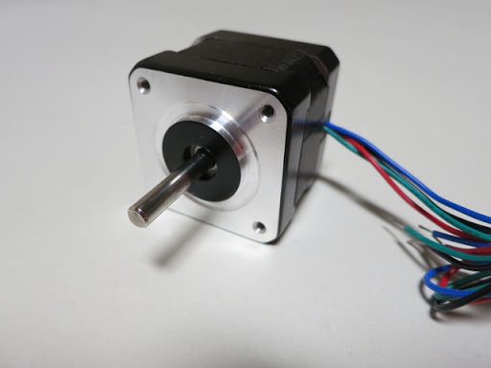

→chain gears x 1

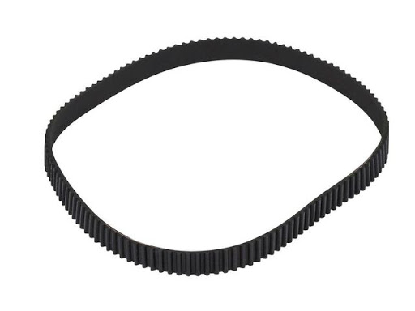

→hobbed gears for stepper motors x 2

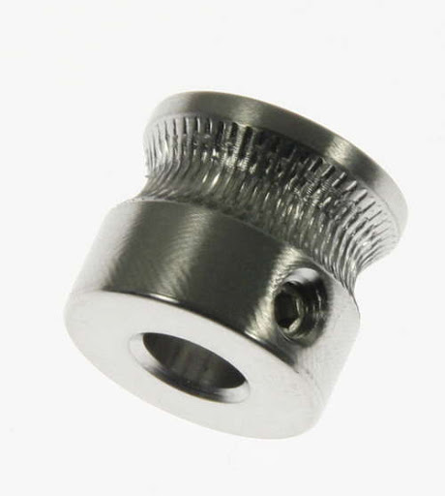

→long threaded rods for z-axis movement x2

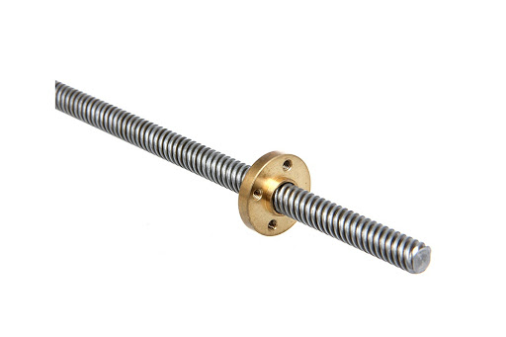

→idler gear movement of extruder and bed x 6

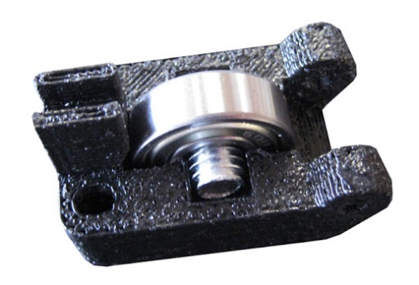

→Heating Bed (31x31cm) with aluminium sheet(3mm)

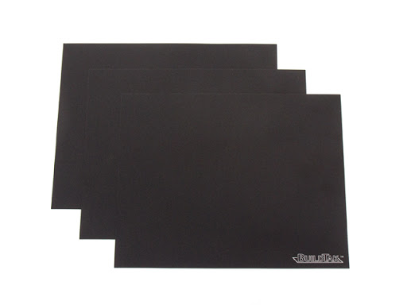

→filament detecting sensor

→lcd display

→ heat sink or heat end fan

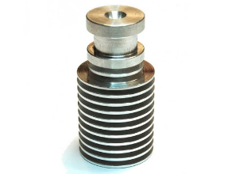

→Extruder

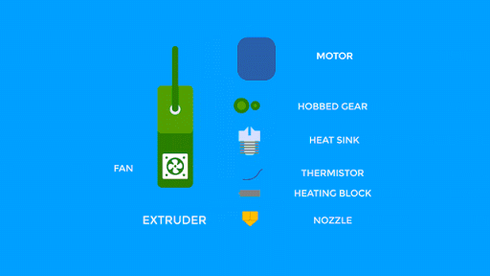

→MotherBoard or Controller Board

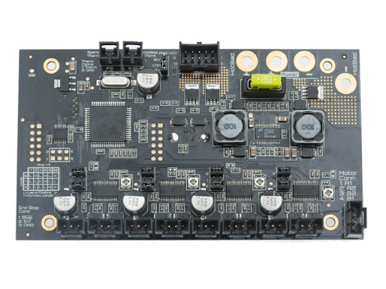

→Heater Cartridge

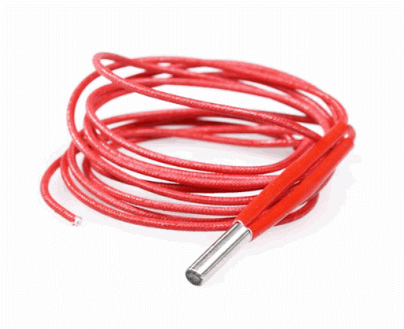

→SD card slot

→power supply unit

→End Stops

→The Thermocouple

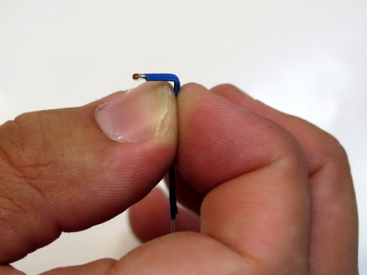

→The Cooling Fan

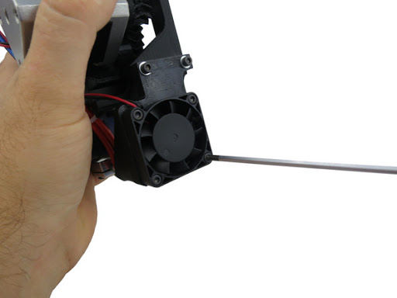

→Nozzle

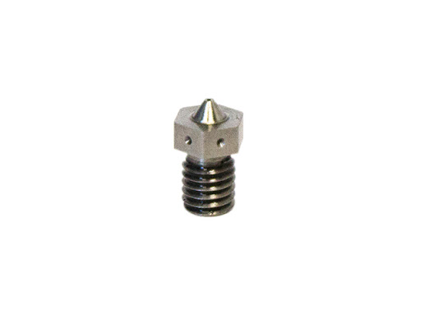

→stepper drivers

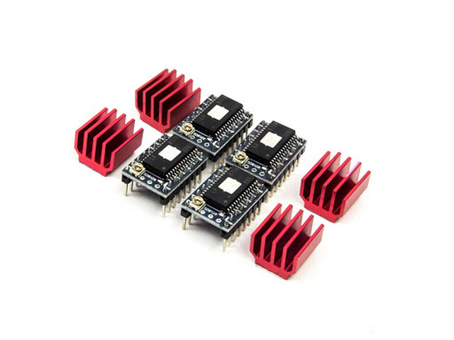

**iii.)Functionality of each part**

**Print Bed**

The print bed is the surface that your objects are printed on to. Typically it will consist of a sheet of glass, a heating element, and some kind of surface on top to help the plastic stick.

**Heated/Non-Heated**

Most print beds are heated in order to prevent the object from warping while it is being printed. Due to thermal contraction, the plastic will shrink slightly as it cools. This causes the object to warp upwards around the edges and peel off the bed. Heated beds keep the bottom of the object warm, in order to prevent this.

**Bed Surfaces**

The bed surface helps the plastic stick to the bed during printing but also allows it to be removed easily when printing is done. There are many different kinds of bed surfaces. Most printers will come with some kind of all purpose surface, like BuildTak or PEI film. However, for best results you will want to use different surfaces depending on the material you are printing.

**Filament**

This is the plastic that's consumed by the printer. It comes on a spool. Printers use two different sizes of filament, 1.75 mm and 3 mm. There are a variety of different materials.

**Extruder**

The extruder is the core of the printer. It is where the plastic gets drawn in, melted, and pushed out. It is essentially a fancy hot glue gun. It is small, but it is where most of the printer’s technology is located. The extruder consists of two parts; the hot end and the cold end. The cold end has a motor that draws the filament in and pushes it through. The hot end is where the filament gets melted and squirted out.

**Hot end - Heat Sink / Hot End Fan**

This ensures that heat does not travel up the plastic and melt it prematurely before it reaches the nozzle. This phenomenon is called heat creep and it causes jams, especially with PLA. This fan should be running whenever the hot end is warm.

**Thermistor/Thermocouple/RTD**

These are all various types of sensors for determining the temperature of the hot end. They are essentially electronic thermometers. Thermistors are the most common type of sensor, but some printers will use thermocouples for extremely high temperature printing.

**Heater Cartridge**

The heater cartridge is pretty self explanatory. It heats the plastic. It is simply a high power resistor. Almost all modern printers use cartridge heaters, but many older printers used coils of nichrome wire (like the kind in a toaster). If you are replacing your heater cartidge, of even your entire hotend, make sure you know if your system is running 12v or 24v.

**Nozzle**

The nozzle is simply a piece with a small hole for the melted filament to come out of. Nozzles are interchangeable, and come in various sizes; 0.4 mm is normal, while you might use a smaller nozzle for finer detail or a larger nozzle to print faster. Nozzles can also sometimes get clogged. This is one of the most common issues with 3D printers.

**End Stops (one for each axis)**

The end stops are how the printer knows where it is. They are little switches that get pushed whenever an axis moves to the end. This is how the printer finds it’s starting point before printing. Most printers use mechanical switches, but some are known to use optical sensors.

**Motherboard/Controller Board**

The motherboard is the brain of the printer. It takes the commands given to it by your computer (in the form of [G-Code](http://reprap.org/wiki/G-code)) and orchestrates their execution. The motherboard contains a microcontroller (essentially a tiny, self-contained computer) and all the circuitry needed for running the motors, reading the sensors, and talking to your computer.

**Stepper Drivers**

These chips are responsible for running the stepper motors. They fire the coils of the motor in sequence, causing it to move in increments. Many motherboards have the stepper drivers built in, but some also have them in modules that can be unplugged. By balancing the power fed to each coil, the driver is also able to divide steps up into further increments. This is called microstepping, and allows more precise control over the motor than is normally possible. The stepper driver also controls how much electrical current is fed to the motor.

**Screens and User Interfaces**

Some printers have an LCD screen so they can be controlled directly without hooking them up to a computer. These can be basic black and white displays like the [VIKI 2](http://www.matterhackers.com/store/printer-accessories/panucatt-viki-2-graphic-lcd-screen-for-3d-printers) or advanced enabled touchscreens like the one included on the new [Ultimaker S5 3D printer](https://www.matterhackers.com/store/l/ultimaker-s5/sk/MH6DVDNK).

